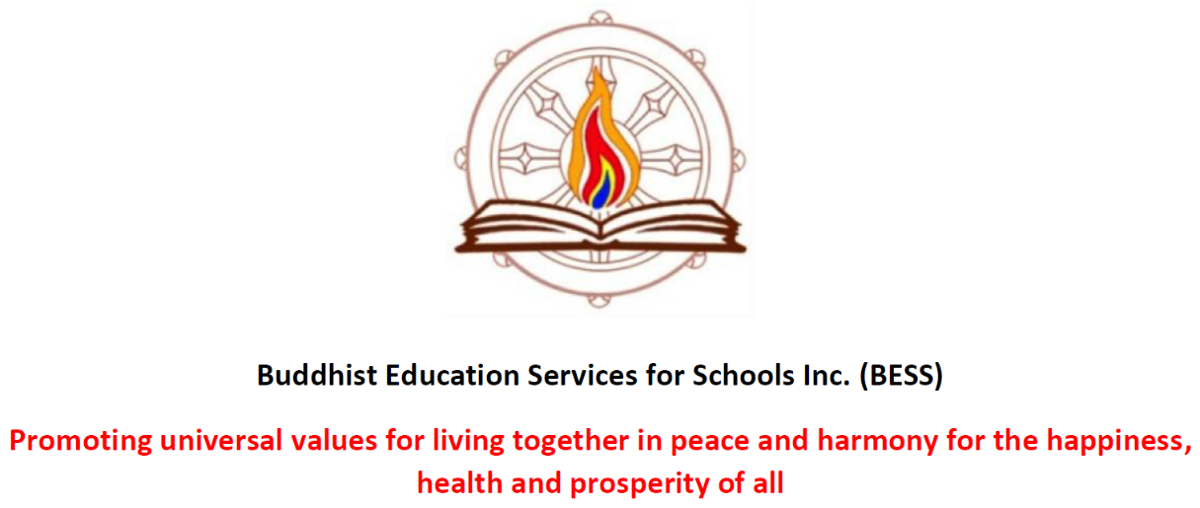

Buddhist Education Services for Schools Inc. ABN: 62294350734
Annual Report 2022. AGM April 1. 2023
General Management Committee Report March 2022 – April 2023
President: Venerable Tseten
Vice President: Lyna Chen
Secretary: Maria Thornton
Treasurer: Cheryl Grampe
Member: Karyn Smith
Member: Nicholas Lee
The committee meet regularly, every 4-5 weeks, with most meetings being via zoom link and we are all becoming more comfortable with this format. The agenda is usually quite full for the day to day running of BESS, and reports from the teams, updates on schools and teachers, and the acquisition of teacher support materials, as well as financial matters are all carefully considered and appropriate action taken. The committee have worked in complete harmony for the benefit of our teachers and the students with whom we share the wisdom of the Buddha.
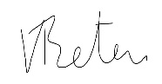Venerable Tseten. Chair.

Fund Committee Report March 2022 – April 2023. Presented by Petra Depalo.
Chair: Petra Depalo
Secretary: Venerable Tseten
Treasurer: Cheryl Grampe
The purpose of the Fund Account is to provide the General Account with operational funds. The account is to receive all donations and raise money in order to use these funds for the purpose of propagating the Dharma in schools and provide the necessities to operate BESS throughout the year.
Items such as paying for insurance, purchase of books for teachers to use, travel claims and other sundries used for the operation of BESS.
The Fund Committee meet at least four times a year to discuss the dispersal of monies as required by the General Committee and to ensure the best use of our funds for the purposes of supporting our work in schools.
We have not been able to do any fund raising for the past three years and we hope that this might change in 2023.
Petra Depalo. Chair of the committee.
NB: This report does not contain any information regarding the account balances. This is for security reasons.
Treasurer’s General Report for 2022. Presented by Cheryl Grampe, treasurer.
NB: This report is not published for security purposes and privacy. If anyone wishes to know more, please contact the treasurer.
Blue Card Administrator. Presented by Lyna Chen
BESS blue card information is securely kept by Lyna Chen. All blue card applications and renewals are now done online, assistance offered by Lyna when needed.
BESS Newsletter. Presented by editor, Tracey Chin.
The termly newsletter provides the link between all members of BESS, teaching, and non-teaching supporters, sharing the essential information as well as social activities and upcoming important dates. Tracey encourages everyone to write reports of interesting lessons and/or somethings the students say or do.

Our Precious Teachers 2022 – 2023
Lyna Chen West End SS & Durack SS
Ann Nguyn Macgregor SS
Tracey Chin Warrigal Rd SS & West End SS
Cathrin Feltham Mayfield SS
Venerable Tseten Indooroopily SS
Debra Glavac Indooroopily SS
Pauline Whiteman Indooroopily SS
Jeff Brunne West End SS
BESS Mentorship Scheme 2023
Liam Howells Ironside SS
Sue Sim Ironside SS
These two wonderful new recruits have joined the BESS mentorship scheme allowing us to return to Ironside SS in 2023 after an absence of one year. This is wonderful news, and the school is very happy that Buddhism is back in that school, with the numbers in class having already grown as parents have heard of our return.
Supporting our members
BESS is a full member of Volunteer Queensland, an international organisation that offers skills and support for all organisations who are staffed by volunteers. This year they have been particularly helpful with their own introduction of a Governance Policy which BESS has been able to introduce into its manual. We have also added a Grievance Policy as we continue to improve our own governance and extend our Policy Manual.
Essential Inner workings of BESS
Lesson Development Team Sub-committee Report. Presented by Venerable Tseten
Lyna Chen
Tracey Chin
Venerable Tseten
The vision to introduce a completely new approach to how the curriculum is taught in Buddhist Religious Instruction (RI) has finally been realised. This was anticipated to be a four-year cycle generally including the entire curriculum. As we teach years 3-6 in all schools, over that time year 3 will have a comprehensive beginners idea of Buddhism when they have completed year 6. The team have been working on this for the past three years, and although cycle 1 is ready, the full program will not be completed until 2026.
This past year the team have focused upon completing the first cycle of lessons to introduce in 2023 and as we return to Ironside SS this year, a wonderful opportunity arose to start the entire project anew with classes who have not had our lessons before. This has been quite a challenge and the entire teaching team has been an essential, and very patient, part of this undertaking, easing the successful launch in term 1, 2023 without a hitch.
Student Journals
Another first from this team is our new student journals. We have put together a folder for each student with the front pages showing the characteristics of Buddhism followed by Dharma Detectives. The detectives (students) will be encouraged to use reflection on many of the lessons on worksheets and store those any other work in the journal. At the end of the year, they will take home their own Dharma book and parents will see what they have learnt through the year, with the newly introduced End of Year Certificates be the finale in the journals.
Buddha’s Birthday Celebrations
This BESS tradition continues to be popular with the schools, both students and staff enjoying finding out about Buddhist festivals in general and bathing the baby Buddha. BESS offers party bags to the students on behalf of the baby Buddha, and a book for the school library, this year the book was Ziji, the Puppy Who learnt to Meditate.
Lessons in 2022
The theme overall was the foundations of Buddhism. The story of the life of the Buddha, The Four Truths and Eightfold Path, followed by the Five Precepts. We finished with a greater explanation of the third precept, The Golden Rule – Respect.
Lessons, A New Way Forward in 2023
This year, with the introduction of the new lesson program, the lessons will introduce an innovative way of linking the brain to meditation by looking at how meditation helps the various parts of our brain. The children will understand how their brain works and what they can do to help themselves to make good decisions and be calm. We will also use various ways of meditating to help the students to develop their understanding of how their brain can also help them.
Some time ago, a lesson was written where the children could see the country where the Buddha lived, and some of the significant places of his life story – A Walk With The Buddha. An interactive worksheet for each student has been designed as a passport, and the lesson divided into three chapters to be shared throughout the year.
It will be a busy, and most rewarding year ahead.
Busy Bee Teamwork
Over the year we had several teacher’s meetings, now held at Mt Gravatt, with experiences shared by teachers and much learning from each other. The meetings have become more important than ever as the new lessons are introduced, as each teacher’s experience helps the lesson development team to make appropriate and timely changes to the lessons and schedules.
We also got together to make the bookmarks offered to the children at the end of the year, and the camaraderie and teamwork have made our sharing the wisdom of the Buddha with the children all the more enjoyable.
The potluck lunches at all meetings are amazing, and certainly help the work move along.
Thank you for your time and patience in reading this report, and for all that you do for BESS. 2023 has great potential for BESS and its members, new lessons, and hopefully new members. I encourage you to support our committee and their fundraising efforts whenever possible and take the greatest joy in sharing the wisdom of the Buddha with the children.
Venerable Tseten. March 2023
